Xtremesoft Engineering
9/7/2012

Xtremesoft, Inc.
AppMetrics For Transactions Installation Guide 5.0
Revision 1.2.2

Xtremesoft, Inc. may change the information in this document without notice. Xtremesoft, Inc. shall not be liable for technical or editorial errors or omissions contained within this documentation; nor for incidental or consequential damages resulting from the furnishing, performance, or use of this material.
The user is responsible for complying with all applicable copyright laws. Without limiting the rights under copyright, no part of this documentation may be photocopied or reproduced in any form without prior written consent from Xtremesoft, Inc.
Xtremesoft may have patents, patent applications, trademarks, copyrights, or other rights to intellectual property covering items mentioned in this document. Except as expressly provided in any written license agreement from Xtremesoft, the furnishing of this document does not grant to the user any license to these patents, trademarks, copyrights, or other intellectual property.
Copyright © 2012 Xtremesoft, Inc. All rights reserved.
AppMetrics is a registered trademark of Xtremesoft, Inc.
Microsoft and Windows are registered trademarks or trademarks of Microsoft Corporation in the United States and/or other countries.
The names of actual companies and products mentioned within this documentation may be the registered trademarks or trademarks of their respective owners.

Table of Contents
Chapter 1: AppMetrics Overview 1
AppMetrics Architecture 1
AppMetrics Manager 1
AppMetrics Agents 2
AppMetrics Console 2
AppMetrics Reports 3
Manager - Agent Software Deployment 4
Chapter 2: System Requirements 5
AppMetrics Manager Requirements 5
Hardware 5
Operating Systems 5
SQL Server 5
AppMetrics Agent Requirements 7
Hardware 7
Operating Systems 7
AppMetrics Console and Report Requirements 7
Hardware 7
Operating Systems 7
Software 7
Chapter 3: Security Requirements 8
AppMetrics Service Account 8
Requirements for the AppMetrics Service Account 8
Cross-Domain Monitoring 9
Non-Trusted Domain Environments 9
Windows User Account 9
SQL Server Security 10
SQL Security Roles 10
Remote SQL Security and Delegation 11
Distributed COM (DCOM) Security 11
Verify DCOM is Enabled on Each Computer 11
DCOM Launch and Activation Permissions 13
Chapter 4: AppMetrics Manager Software Installation 15
Pre-install Checklist 15
Manager Install Procedure 15
Chapter 5: AppMetrics Agent Software Installation 30
Pre-install Checklist 30
Agent Install Procedure 30
Chapter 6: AppMetrics Console and Reports Installation 38
Pre-install Checklist 38
Console and Reports Install Procedure 38
Chapter 7: Installing AppMetrics on a Single Computer in a Test Environment 46
Pre-install Checklist 46
Custom Install Procedure 46
Chapter 8: Uninstalling AppMetrics 51
To Uninstall AppMetrics 51
Appendix A: Monitoring .Net Serviced Components with AppMetrics A-1
Code Prerequisites A-1
Appendix B: Using AppMetrics with a Firewall B-1
Checking Connectivity and Configuring DCOM Port Ranges for Use with a Firewall B-1
Appendix C: Additional Assistance C-1

AppMetrics Overview

AppMetrics for Transactions (henceforth referred to simply as AppMetrics) monitors COM+ applications and .NET serviced components, whether they run on a single machine or in a distributed environment. This guide describes the AppMetrics architecture and several deployment scenarios.
Before you deploy AppMetrics, you should first learn about the AppMetrics architecture and requirements. This segment explains and describes the fundamental concepts of AppMetrics.

AppMetrics Architecture
AppMetrics utilizes a Manager/Agent model to collect data from COM+ applications across one or more application servers.
AppMetrics Agents collect instrumentation data from COM+ applications and forward that data to Application Monitors running on the AppMetrics Manager. The Manager receives that data, processes it, and then stores the data in a SQL Server database. Reports can then be generated from that stored data.
The following sections describe the key elements of AppMetrics.

AppMetrics Manager
The AppMetrics Manager is the data processing and storage component of AppMetrics, where various Application Monitors may be defined. Each Application Monitor collects data from an associated Agent configured to monitor one or more COM+ applications on an application server. In most situations, the manager software is installed on a separate machine than the COM+ applications, however, in test environments both the manager and agent software may be installed on the same machine.
Data collected from the agents and processed by the monitors is stored in a SQL Server database, which may reside either locally on the manager machine or remotely on a separate machine if so desired.

Application Monitors
AppMetrics uses the concept of Application Monitors to collect COM+ application metrics via an AppMetrics Agent running on an application server.
There are two types of Application Monitors, a Production Monitor, and a Diagnostic Monitor. They each collect data differently, where the Production Monitor is designed to lessen the impact of monitoring in a production environment 24/7, while the Diagnostic Monitor is designed to collect as much data as possible for troubleshooting an application.
The characteristics of each monitor are as follow:
Diagnostic Monitor – Used to collect detailed application data in order to analyze and diagnose problem areas in applications. AppMetrics Diagnostic reports provide a powerful drill down functionality to identity method call sequences and timing, among other metrics.
Production Monitor – Used to monitor applications running in a production environment. This type of monitoring uses fewer resources on an application server and provides the ability to generate user alerts when user configurable thresholds are exceeded.
Application Monitors collect and store data to log files on the AppMetrics Manager machine. These log files are then uploaded into the AppMetrics SQL Server database either automatically, based on a configurable time interval, or manually, as desired.

SQL Server Integration Services (SSIS)
The AppMetrics Manager utilizes SQL Server Integration Services (SSIS) to create databases and upload data. Database creation is performed by SSIS tasks which physically create the monitor database, and then add stored procedures that are later used by AppMetrics reports to query and organize the relevant data within the database.
Data uploads are accomplished by running a series of SSIS tasks which use bulk insert to efficiently transfer large volumes of data with field validation.

AppMetrics Agents
An AppMetrics Agent collects COM+ instrumentation events and Windows process performance data from COM+ applications and .Net Serviced Components running on Windows Application Servers.
Once data is collected, the agent will communicate that data to the associated AppMetrics Monitor running on the AppMetrics Manager machine using the DCOM protocol.
One, several, or all installed COM+ applications on an individual machine may be monitored by a single AppMetrics Agent. Each Agent is monitored by a corresponding Application Monitor running on the Manager machine.
The AppMetrics Agent software must be installed on each application server that needs to be monitored in order for AppMetrics to monitor applications on those servers.

AppMetrics Console
The AppMetrics Console is a Microsoft Management Console snap-in and is the main user interface for AppMetrics. The AppMetrics Console provides the ability to create and configure monitors, and provides various views of the application metrics collected.
For Production Monitors, the console also allows various thresholds to be set per application, component, and transaction, where if they are exceeded, various types of notifications may be delivered. Those notifications include SMTP mail notifications, Windows Event Log entries, SNMP events, as well calling Windows Component Scripts in order to execute customized actions.
Additionally, log file settings, monitor health status, and additional configuration settings are available from the console.
The console may also be attached to other machines in order to remotely configure AppMetrics Agents as necessary.

AppMetrics Reports
AppMetrics Reports retrieve data directly from the AppMetrics SQL Server database and display the data in Microsoft Excel. The reports consist of various charts and tables allowing you to see how your packages/applications and machines have performed over time.
The reports may be installed on any machine which may access the SQL Server database over the network. They are installed on the AppMetrics Manager machine by default.

Manager - Agent Software Deployment
The AppMetrics Manager software is typically installed on a separate computer, and the AppMetrics Agent software is installed on each separate application server which the user wishes to monitor.
Both the Manager and Agent software can however be installed on the same computer in test situations, such as on a development/test computer.
Running the AppMetrics Manager on a separate computer provides the following benefits:
- Reduces impact of monitoring on the application server running the applications.
- Better performance for administrative functions, such as carrying out requests for console users and generating reports.
For a typical deployment you will need to perform the following tasks, which are described in further detail later in this document:
- Ensure that the System Requirements are met for the type of installation you are performing. Please refer to page 5 for more information.
- Obtain a domain account for the AppMetrics service. During the install, you will assign this account to the AppMetrics service on the Manager machine and each Agent machine. For information about required account attributes, see AppMetrics Service Account on page 8.
- Ensure that a Microsoft SQL Server 2005 or 2008 instance is available for use by AppMetrics, either local to the manager computer, or remotely.
- Additionally, SQL Server Integration Services will need to be installed on the manager machine, as AppMetrics utilizes SQL SSIS for database creation and data uploads.
- Install the AppMetrics Manager software on to the manager machine. See AppMetrics Manager Software Installation on page 15.
- Install the AppMetrics Agent software onto each machine whose applications are to be monitored. See AppMetrics Agent Software Installation on page 30.

System Requirements

This chapter describes the system requirements for each type of AppMetrics configuration.

AppMetrics Manager Requirements

Hardware
- Minimum Intel x86 Processor Pentium III 300MHz or higher. Intel Core 2 Duo or Quad Processor recommended.
- Minimum 256 MB RAM, 1 GB or higher recommended.
- Minimum 10 GB free disk space, plus 4 GB additional space per monitor for archival data.

Operating Systems
Both 32-bit and 64-bit versions of the following operating systems are supported.
- Windows XP Professional
- Windows Vista
- Windows 7
- Windows Server 2003
- Windows Server 2003 R2
- Windows Server 2008
- Windows Server 2008 R2

SQL Server
AppMetrics utilizes SQL Server in order to store metrics collected during application monitoring. The SQL instance may be local to the AppMetrics manager machine or remote.
Each AppMetrics monitor is associated with a discrete SQL database, created at monitor create time. During data collection, the AppMetrics manager will receive COM+ event information via DCOM from its associated agent, convert that event information to an AppMetrics object, write out those objects as records within a text based file, then finally upload those records to SQL Server using bulk insert within a SSIS task.
AppMetrics reports may then be run against that data from any machine which can access the database over the network.
The following SQL Server versions are supported, and the required SQL Server components are listed for each supported version.

SQL Server 2005 (32-bit and 64-bit), all editions except SQL Express and Workgroup
- Database Services (only required if using a local SQL instance)
- Integration Services
- Management Tools – Complete (required on 64-bit editions to install 32-bit SSIS runtime)

SQL Server 2008 (32-bit and 64-bit), all editions except SQL Express and Workgroup
- Database Services (only required if using a local SQL instance)
- Integration Services
- Management Tools – Complete (required on 64-bit editions to install 32-bit SSIS runtime)
- SQL Server 2008 Backwards Compatibility Components (required to install SQL DMO, which is not installed by default on SQL Server 2008)
The Backwards Compatibility Components feature is available at the following URL: http://www.microsoft.com/en-us/download/details.aspx?id=16177
Note: Neither SQL Express nor Workgroup editions are supported as they lack SQL Server Integration Services (SSIS)

AppMetrics Agent Requirements

Hardware
- Minimum Intel x86 Processor Pentium III 300MHz or higher. Intel Core 2 Duo or Quad Processor recommended.
- Minimum 256 MB RAM, 1 GB or higher recommended.
- Minimum 10 GB free disk space, plus 1 GB additional space minimum per agent for COM+ instrumentation event logging.

Operating Systems
Both 32-bit and 64-bit versions of the following operating systems are supported.
- Windows 2000 Advanced Server (no 64-bit support)
- Windows Server 2003, Windows Server 2003 R2
- Windows Server 2008, Windows Server 2008 R2

AppMetrics Console and Report Requirements

Hardware
- Minimum Intel x86 Processor Pentium III 300MHz or higher. Intel Core 2 Duo or Quad Processor recommended.
- Minimum 256 MB RAM, 1 GB or higher recommended.
- Minimum 100 MB free disk space.

Operating Systems
- All operating systems capable of running Microsoft Excel

Software
- Microsoft Excel 2003 or higher.

Security Requirements

This chapter provides security requirement information related to AppMetrics installation and data access. It covers Windows, SQL, and DCOM security.

AppMetrics Service Account
A Windows service account is required on each machine where the AppMetrics Manager or Agent software will run. For the sake of brevity, application servers running the AppMetrics Agent software will be referred to as Agent machines.

Requirements for the AppMetrics Service Account
The AppMetrics for Transactions services running on the Manager machine and the Agent machines must be able to authenticate with each other. Thus, the AppMetrics service account requirements are listed below:
- Should either be a domain account or the local System account. It is also possible to use local accounts if installing in a non-trusted domain relationship or outside of a domain altogether, but extra configuration is required.
- If the local System account is used, each Agent machine name must be added to the Administrators group on the Manager machine. Conversely, the Manager machine name must be added to the Administrators group on each agent machine.
- Must not be a restricted account unable to logon to the AppMetrics computers.
- Must have local Administrators privilege on all computers that will be running AppMetrics. The local System account has built-in privileges that do not require additional configuration.
- Must have AppMetrics Administrators group privilege on the AppMetrics computers. The AppMetrics Administrators group is created during install, and the run-as account is automatically added to the group.
- The account and its password should never expire (recommended)
- It is not restricted from operating during certain times of the day.

Cross-Domain Monitoring
AppMetrics is able to monitor across domains. At a minimum, you must have a one-way trust between the domains.
The following is an example of how AppMetrics can work in a one-way trust. Place the Manager machine in a trusted domain. It is assumed the application servers to be monitored reside in a non-trusted domain. Next, assign an account from the trusted domain to the AppMetrics service on each desired application server. As a result, when the AppMetrics services on these machines communicate with the Manager machine, they will use accounts that can be trusted by the Manager machine.

Non-Trusted Domain Environments
In certain situations it may be necessary to install AppMetrics in environments where there is no trusted domain available. This can be accomplished as follows:
Create a local user account on both the Manager and Agent machines which will be used as a logon account to log into the machines for the purpose of running AppMetrics.
When creating the local user account, ensure that the passwords are the same on both the manager and agent machines.
After you’ve created the user account on both machines, place that account into the Administrators group on both machines.
Install AppMetrics onto the Manager and Agent machines, using the local user account as the service account, ensuring that the password is the same on all machines.
When entering the service account information during install, enter the local machine name in the Domain field.

Windows User Account
AppMetrics user accounts may be Administrator accounts or standard Windows accounts, but should be domain accounts which have the ability to log onto each machine within the AppMetrics monitoring environment. In a non-domain setting, the user account will to be defined on each machine using the same password on each.
For non-Administrator accounts, the DCOM settings on each machine will need to be configured as described in DCOM Launch and Activation Permissions on page 13.
Each account which will be used to run AppMetrics will also need to be added to the AppMetrics Administrators group on each machine. All existing Windows Administrators are automatically added to this security group at AppMetrics install time, so will not need to be added manually.

SQL Server Security
AppMetrics utilizes Microsoft SQL Server in order to store metrics collected during application monitoring. The SQL instance may be local to the AppMetrics manager machine or remote.
The user installing the AppMetrics Manager software will need to have SQL Server dbcreator, bulkadmin, processadmin privileges in order to setup AppMetrics properly, and will also need to be an Administrator on the local machine.
AppMetrics uses Windows Authentication for SQL security. Thus, either the service account which will be used to run AppMetrics will need to have adequate privilege to create databases and run bulk insert, or the AppMetrics Administrators group will need to be granted those privileges after AppMetrics installation.
During AppMetrics installation several sample databases are created in order to verify proper SQL Server configuration. If any issues arise during this step, please review the error message and take corrective action, since those same issues would cause AppMetrics to malfunction.
The AppMetrics installation software will attempt to insert the AppMetrics service account into SQL Server Security and assign it the required security roles AppMetrics will need. If it already defined within SQL Security, no action is taken.

SQL Security Roles
As noted above, the AppMetrics service account will need the following privileges in order for AppMetrics to function properly.
- dbcreator – required for monitor creation
- bulkinsert – required for data upload
- processadmin – required for monitor deletion. It is necessary to have this privilege due to the fact AppMetrics enumerates all active processes associated with a monitor database to check if there are any locks on the database prior to deletion.
If the SQL instance allows Windows Administrators sysadmin privilege, then no additional steps are necessary. However, if local policies prevent Windows Administrators from having SQL sysadmin privilege then the AppMetrics service account will need to have the privileges added, either automatically during AppMetrics installation, or manually prior to installing AppMetrics. Also, if AppMetrics is installed using the Local System service account, and SQL Server is not running under the Local System account, then that account will need to be added to SQL Server and configured as described above.
An alternative would be to place the AppMetrics service account into the AppMetrics Administrators group, add that group to SQL Security, then grant the specified privileges to that security group.

Remote SQL Security and Delegation
In order to use a remote SQL Server instance running under the local System account, the SQL Server database server will need to be enabled for delegation in Active Directory. Please refer to your System Administrator for assistance in this area.

Distributed COM (DCOM) Security
AppMetrics utilizes Distributed COM (DCOM) to communicate between the AppMetrics Manager and the AppMetrics Agents. Accordingly, DCOM must be properly configured in order for AppMetrics to function correctly.
Additional configuration is required if a firewall is in place between the Manager and Agent machines. Please refer to Appendix B: Using AppMetrics with a Firewall for further information.

Verify DCOM is Enabled on Each Computer
To verify DCOM is enabled on the Manager and Agent machines, on each machine, navigate to the Component Services console from the Administrative Tools menu, and then expand the console to Component Services->Computers->My Computer, as shown below in Figure 3-1.
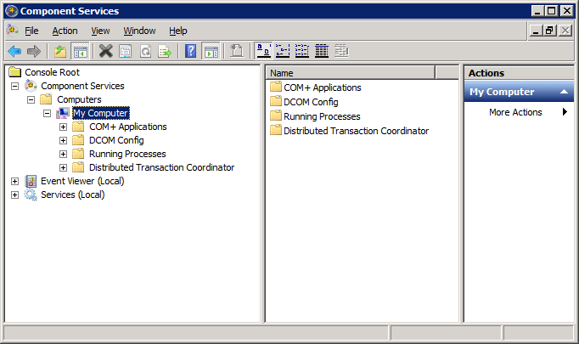
Figure 3-1 Component Services Console
Right click on the My Computer item, and then select Properties from the pop-up menu. From there, select the Default Properties page, as shown below in Figure 3-2, verifying that the Enable Distributed COM on this computer checkbox is checked. If it isn’t already checked, enable it by checking the box, then click OK.
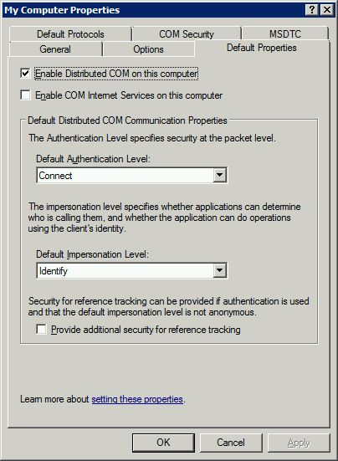
Figure 3-2 Default Properties

DCOM Launch and Activation Permissions
The following steps should be performed after installing the AppMetrics Manager and Agent software. They are necessary if users other than Administrators will be running AppMetrics. If AppMetrics will only be used by those whose user accounts are defined as Administrators on the Manager and all Agent machines, then these steps may be omitted.
- Select the COM Security page from the My Computer Properties view in Component Services.
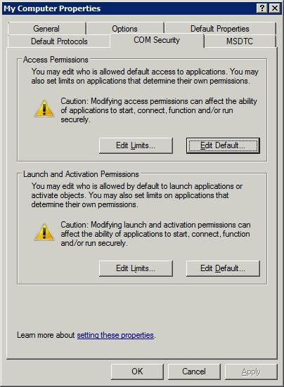
Figure 3-3 COM Security
- Select the Edit Limits button within the Launch and Activation Permissions group.
- Select the Distributed COM Users entry, and verify that both the Local and Remote Launch, and both the Local and Remote Activation permissions are set to Allow, as shown in Figure 3-4.
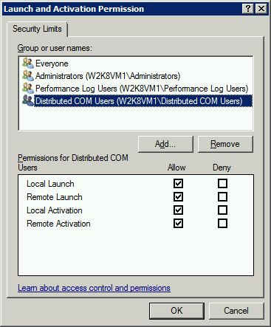
Figure 3-4 Launch and Activation Permissions
- If necessary, select Allow for any permission that isn’t already selected, and then select OK.
- Each user account that is to be defined as an AppMetrics account will need to be added to the Distributed COM Users group on each AppMetrics Agent machine and on the AppMetrics Manager machine. A simple utility which performs this task, as well as adding the user to the AppMetrics Administrators group, is located in the \Program Files\Xtremesoft\ AppMetrics for Transactions folder, and is named AddATXUser.cmd.
- Run the AddATXUser.cmd for each user you wish to allow access to AppMetrics, on each machine which is running an AppMetrics Agent and on the AppMetrics Manager.
The syntax of the command is as follows;

AddATXUser UserName

AppMetrics Manager Software Installation

Pre-install Checklist
- Verify that your environment meets the hardware and software requirements listed on page 5.
- Ensure that you have read Chapter 3: Security Requirements and that you have a domain account available for the AppMetrics service, or you that have decided to use the Local System account. Optionally, for non-trusted domains, ensure that you have taken the steps outlined for that environment.
- If at all possible, install AppMetrics from the machine console rather than through Terminal Services. Terminal Services has its own set of security settings that can sometimes cause problems with a remote install.
- Ensure that you have your AppMetrics license key available.
- Ensure that TCP/IP is enabled for the SQL instance you will be using for AppMetrics. This can be verified through the SQL Server Configuration Manager.
- Verify that the SQL Server instance you will be using for AppMetrics is running.
- If you are installing the AppMetrics Manager onto a SQL cluster, please contact Xtremesoft Support.

Manager Install Procedure
- Log on to the computer with a Windows account that has local Administrator privileges, and that has SQL Server sysadmin privileges.
- If you are installing from a CD-ROM, proceed to step 4.
- If you are installing AppMetrics from a web download, double click the downloaded file from Windows Explorer, follow the instructions to extract the setup program, and then proceed to step 7.
- Place the AppMetrics CD-ROM into the CD-ROM drive.
- Use Windows Explorer to open the root folder on the CD-ROM
- Double-click Setup.exe.
After the initial Xtremesoft splash screen, the Welcome window appears (Figure 4-1).

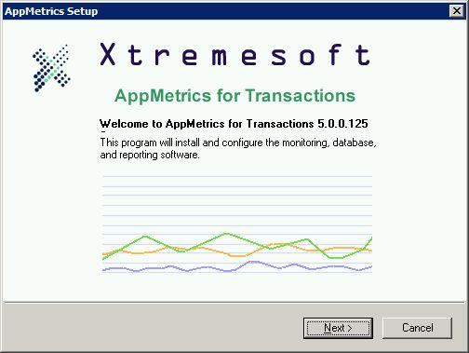
Figure 4-1 Welcome Window
- Click Next.
This opens the License Agreement window (Figure 4-2).
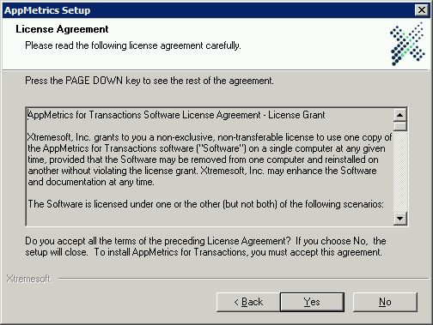
Figure 4-2 License Agreement Window
- After reading the license agreement and you accept the terms of the agreement, click Yes.
This opens the Customer Information window (Figure 4-3).
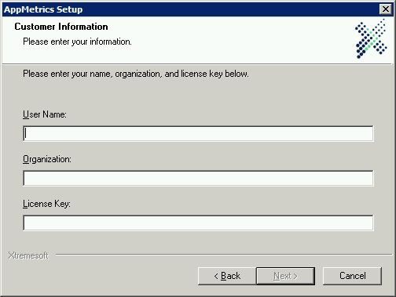
Figure 4-3 Customer Information Window
- Enter your user name, your organizations name, and the license key sent to you.
- Click Next.
The AppMetrics Software Selection window will appear (Figure 4-4).
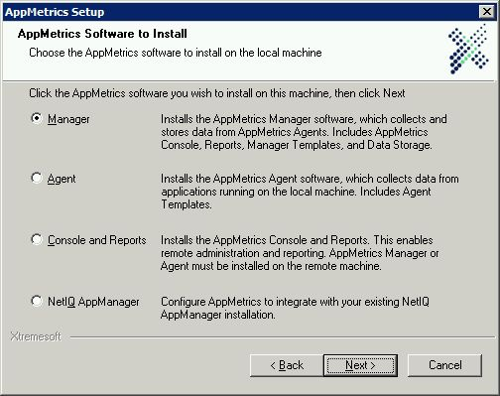
Figure 4-4 AppMetrics Software Selection Window
- Choose the Manager selection, and then click Next.
This opens the Setup Type window (Figure 4-5).
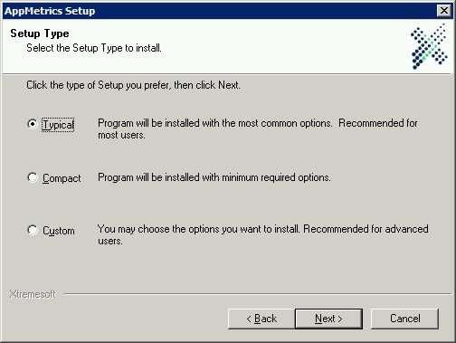
Figure 4-5 Setup Type Window
- Choose the install type. Typical is recommended. Click Next.
This opens the Destination Folders window (Figure 4-6).
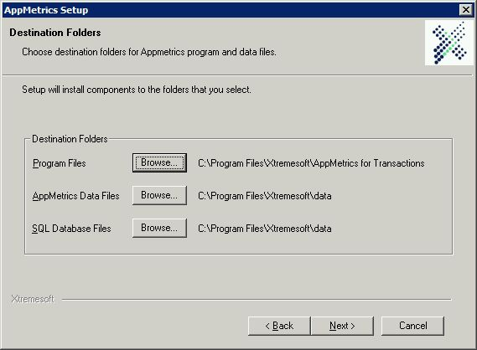
Figure 4-6 Destination Folders Window
- If you wish to select the drive or folder in which to install the software, click the respective Program Files Browse button, and then select the desired folder. Otherwise, accept the default location.
- If using a local SQL instance for AppMetrics, you may wish to either use the default location for the AppMetrics data files, or select a different drive or folder name. A new folder is created if it does not yet exist. Skip to step 20.
- If using a remote SQL instance, you will need to create a shared folder for the AppMetrics data files in order for the remote SQL server to read the data files. In the example below in Figure 4-7, a new folder on C: drive has been created and named AppMetrics Data.
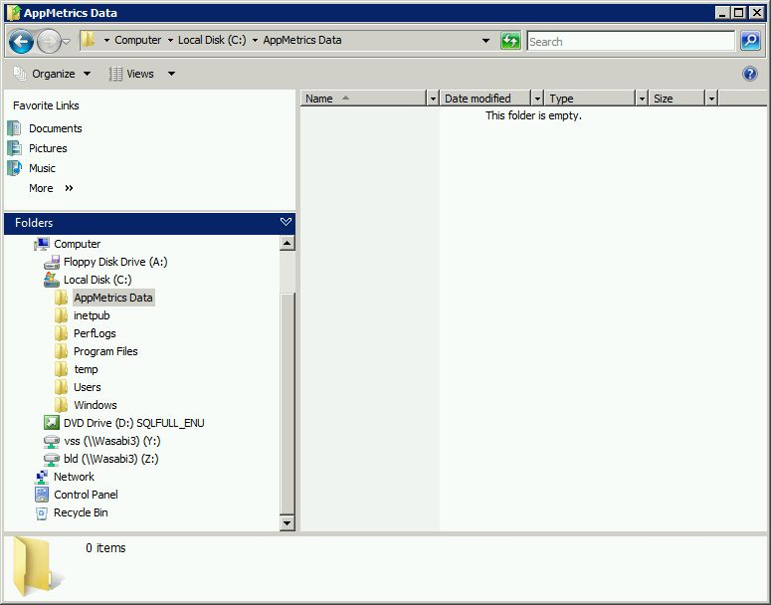
Figure 4-7 New Data Folder
- You will need to right click on the folder name and select Sharing. The service running SQL Server Integration Services on the local machine will need to be added to the File Sharing Permissions for that folder.
In the example below in Figure 4-8, the local System account has been added.
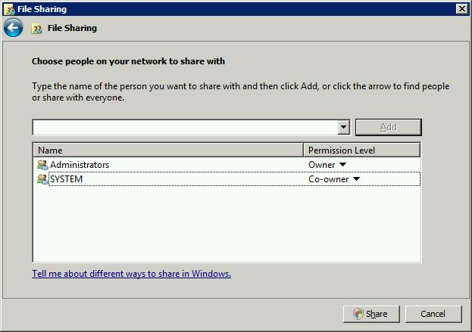
Figure 4-8 File Sharing
- Select the Share button to close the File Sharing window.
- Using the AppMetrics Data Files Browse button on the Destination Folders window, navigate to Network, locate the local computer, and select the shared data folder.
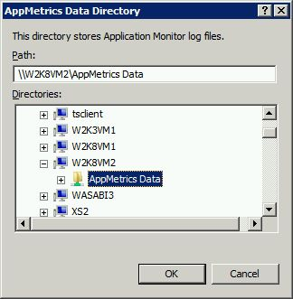
Figure 4-9 Select Shared Folder
- Click OK.
- If using a local SQL instance for AppMetrics, you may choose the default SQL database file location, or use the SQL Database Files Browse button to select a different drive or folder. Skip to step 23.
Note 1: AppMetrics install will not create the SQL database file folder if it does not yet exist since in remote installations, the folder is located on the remote computer. You will need to create the folder manually if it does not yet exist.
Note 2: Ensure that the SQL Server service account has permission to access that folder by viewing the security permissions on the folder. Add the SQL Service account to the permissions list if necessary, granting it read and write access.
- If using a remote SQL instance for AppMetrics, determine the SQL database file location on the remote computer, select the SQL Database Files Browse button, then enter the location into the Path field on the AppMetrics SQL Server File Location window. In the example below in Figure 3-1, the C:\ATXDB folder on the remote computer is entered into the Path field.
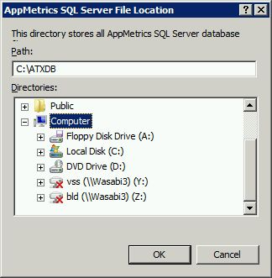
Figure 4-10 AppMetrics SQL Server File Location Window
- Click OK. Verify that the Destination Folders paths are correct.
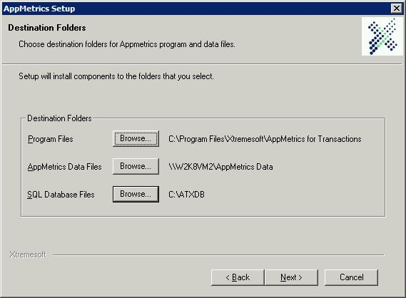
Figure 4-11 Updated Destination Folders
- Click Next.
Note: You may receive a Confirm New Folder prompt if the specified folders do not exist on the machine (except for the SQL Database Files folder as previously noted). Click Yes to accept the creation of the new folder(s).
This opens the Service Run As Account window (Figure 4-12).
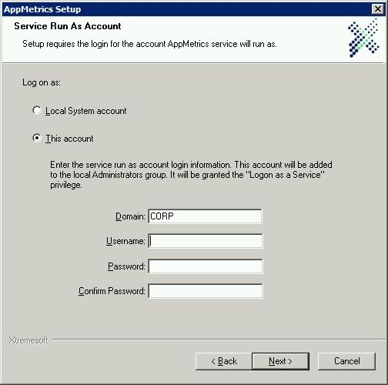
Figure 4-12 Service Run As Account Window
- If using a domain account for the AppMetrics service, specify the domain, username, and password in the appropriate fields.
- If using the Local System account for the AppMetrics service, select the Local System Account radio button. Please refer to the AppMetrics Service Account section on page 8 for additional requirements when using the Local System account.
- If no domain is present, enter the local computer name and user account information. Please refer to the AppMetrics Service Account section on page 8 for further information on setting up the account in cross-domain and non-trusted domain monitoring situations.
Note: This window verifies that the passwords match each other. It does not verify the username and password combination. If you enter an incorrect combination and then complete the install, you can either correct the combination after the install by using the Services console in Windows, or running AppMetrics install again in Repair mode.
- Click Next.
This opens the SQL Server Instance Name window (Figure 4-13).
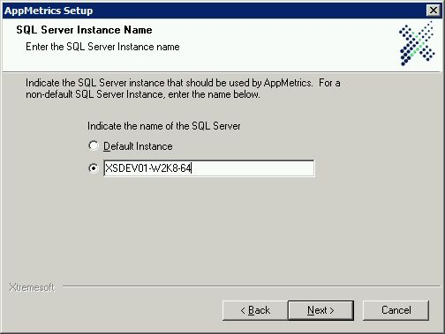
Figure 4-13 SQL Server Instance Name Window
- If using a local SQL Server database instance, you may choose to use the default SQL instance or a named instance for AppMetrics. If you wish to use the default instance, ensure that the Default Instance radio button is selected and proceed to step 31.
- Otherwise, if using a local SQL Server database instance, and you wish to use a named instance, or if you are using a SQL database instance on a remote computer, select the named instance radio button (below the Default Instance button).
- Enter the name of the SQL instance name into the entry field. The instance name is entered in the following format;
ServerName\InstanceName – when using a named instance, local or remote
-or-
ServerName – when using a default instance on a remote computer
Note: The ServerName component must reflect the name of the local computer if using a local SQL instance, and the name of the remote computer if using a remote SQL instance. The Instance Name (and backslash) must be left off in order to use a default instance on a remote computer; the ServerName component is still required.
- Click Next.
This opens the Select Program Folder window (Figure 4-14).
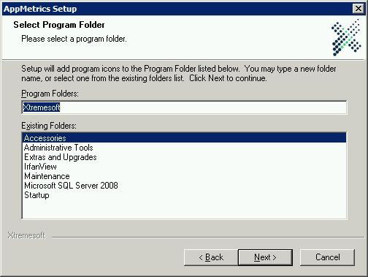
Figure 4-14 Select Program Folder Window
- Enter the name of the Start Menu Folder in which to add the AppMetrics program entries, or accept the default name.
- Click Next.
The Setup Status window (Figure 4-15) will now appear.
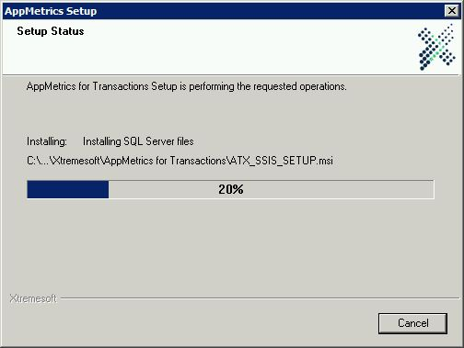
Figure 4-15 Setup Status Window
After setup copies AppMetrics files to the selected Program Folder location and registers components, it will then bring up the AppMetrics SSIS Access Component Setup Wizard.
This wizard will guide installation of the AppMetrics SSIS Access Component, which AppMetrics will use to interact with the SQL Server database through SSIS.
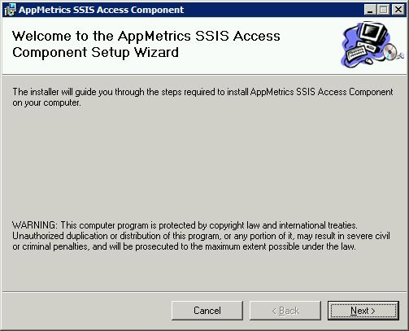
Figure 4-16 AppMetrics SSIS Access Component Setup Wizard
- Click Next.
The Select Installation Folder window will appear.
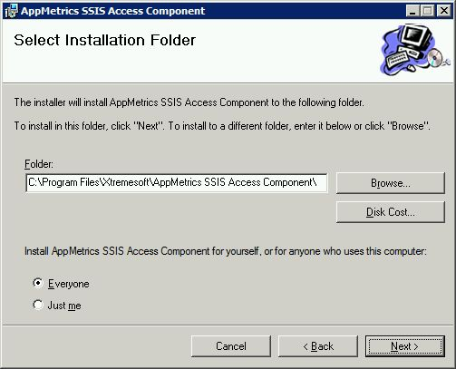
Figure 4-17 SSIS Select Installation Folder
- If you wish to change the destination path to a different folder, use the Browse button to select the desired location.
- Ensure that the Everyone radio button is selected.
- Click Next. Once the SSIS component is installed, the Installation Complete window will appear.
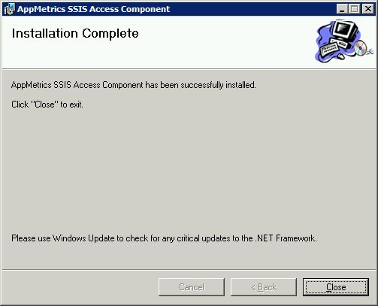
Figure 4-18 SSIS Installation Complete
- Click the Close button. The Setup Status window will display the current installation operations, including the creation of sample databases and populating them with sample data for AppMetrics reports examples.
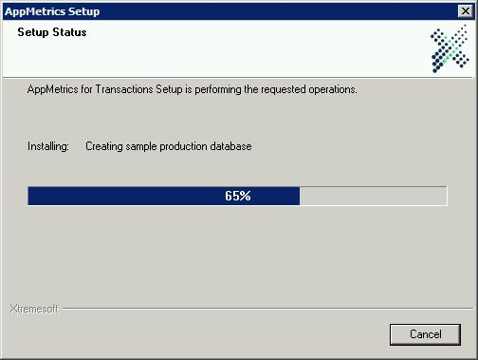
Figure 4-19 Creating Sample Databases
Note: If there is an error at this point, it indicates that SQL Server operations are unable to successfully complete due to a configuration problem. If this occurs, cancel setup and verify that all SQL configuration parameters are correct. If corrections are made, run AppMetrics setup again, and if this step succeeds then there should no longer be any problem, otherwise please contact Xtremesoft support, as the AppMetrics Manager will not operate correctly without valid access to SQL Server.

Once setup has installed the AppMetrics Manager software, the Monitor Templates window will appear indicating which templates were installed. The templates installed should match those shown below in the Monitor Templates window (Figure 4-20).
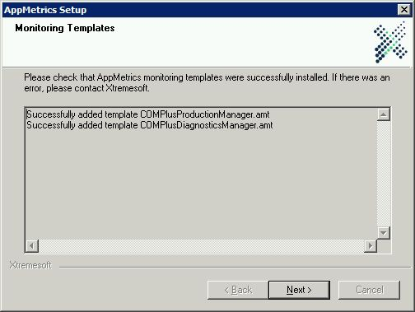
Figure 4-20 Monitoring Templates Window
Note: If the monitor templates don’t match the above list, please contact Xtremesoft support.
- Click Next. A computer reboot is required in order to complete AppMetrics installation. The reboot may be delayed by selecting Reboot later.
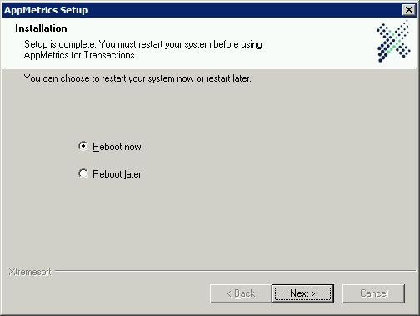
Figure 4-21 Reboot Option Window
- Click Next.
This opens the Installation Complete window.
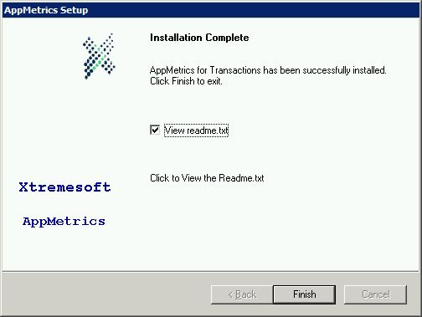
Figure 4-22 Installation Complete Window
Note: AppMetrics will not function correctly until you reboot the machine.
- If you wish to skip viewing the Readme file before exiting, uncheck the View readme.txt checkbox.
- Click Finish.
Before using AppMetrics ensure that the computer has been rebooted.
You will now need to install the AppMetrics Agent software onto the application servers that you wish to monitor.
Once the Agent software has been installed on the application servers you may wish to ensure that the DCOM Configuration Settings are performed as described in Chapter 3: Distributed COM (DCOM) Security. You will then need to add additional user accounts to AppMetrics via the ATXAddUser.cmd file as described in DCOM Launch and Activation Permissions on page 13.

AppMetrics Agent Software Installation

Pre-install Checklist
- Verify that your environment meets the hardware and software requirements listed on page 7.
- Ensure that you have read Chapter 3: Security Requirements and that you have a domain account available for the AppMetrics service, or you that have decided to use the Local System account. Optionally, for non-trusted domains, ensure that you have taken the steps outlined for that environment.
- If at all possible, install AppMetrics from the machine console rather than through Terminal Services. Terminal Services has its own set of security settings that can sometimes cause problems with a remote install.
- Ensure that you have your AppMetrics license key available.

Agent Install Procedure
- Log on to the computer with a Windows account that has local Administrator privileges.
- If you are installing from a CD-ROM, proceed to step 4.
- If you are installing AppMetrics from a web download, double click the downloaded file from Windows Explorer, follow the instructions to extract the setup program, and then proceed to step 7.
- Place the AppMetrics CD-ROM into the CD-ROM drive.
- Use Windows Explorer to open the root folder on the CD-ROM
- Double-click Setup.exe.
After the initial Xtremesoft splash screen, the Welcome window appears (Figure 5-1).

Figure 5-1 Welcome Window
- Click Next.
This opens the License Agreement window (Figure 5-2).
Figure 5-2 License Agreement Window
- After reading the license agreement and you accept the terms of the agreement, click Yes.
This opens the Customer Information window (Figure 5-3).
Figure 5-3 Customer Information Window
- Enter your user name, your organizations name, and the license key sent to you.
- Click Next.
The AppMetrics Software Selection window will appear (Figure 5-4).
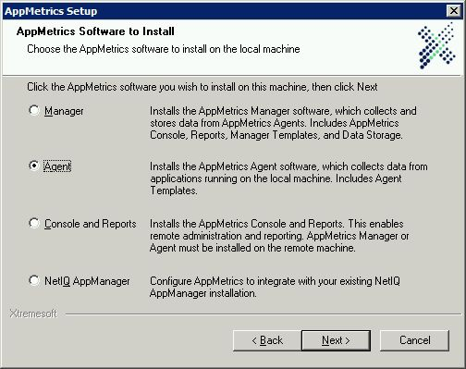
Figure 5-4 AppMetrics Software Selection Window
- Choose the Agent selection, and then click Next.
This opens the Setup Type window (Figure 5-5).
Figure 5-5 Setup Type Window
- Choose the install type. Typical is recommended. Click Next.
This opens the Destination Folders window (Figure 5-6).
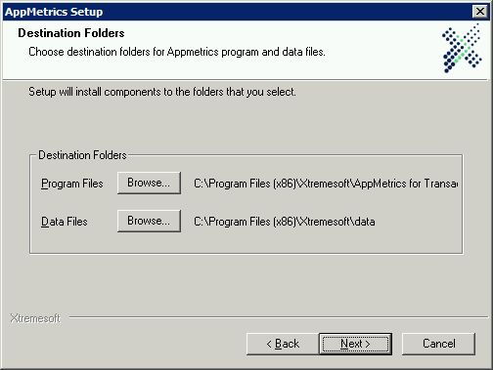
Figure 5-6 Destination Folders Window
- If you wish to select the drive or folder in which to install the software, click the respective Program Files Browse button, and then select the desired folder. Otherwise, accept the default location.
- Click Next.
Note: You may receive a Confirm New Folder prompt if the specified folders do not exist on the machine (except for the SQL Database Files folder as previously noted). Click Yes to accept the creation of the new folder(s).
This opens the Service Run As Account window (Figure 5-7).
Figure 5-7 Service Run As Account Window
- If using a domain account for the AppMetrics service, specify the domain, username, and password in the appropriate fields.
- If using the Local System account for the AppMetrics service, select the Local System Account radio button. Please refer to the AppMetrics Service Account section on page 8 for additional requirements when using the Local System account.
- If no domain is present, enter the local computer name and user account information. Please refer to the AppMetrics Service Account section on page 8 for further information on setting up the account in cross-domain and non-trusted domain monitoring situations.
Note: This window verifies that the passwords match each other. It does not verify the username and password combination. If you enter an incorrect combination and then complete the install, you can either correct the combination after the install by using the Services console in Windows, or running AppMetrics install again in Repair mode.
- Click Next.
This opens the Select Program Folder window (Figure 5-8).
Figure 5-8 Select Program Folder Window
- Enter the name of the Start Menu Folder in which to add the AppMetrics program entries, or accept the default name.
- Click Next.
Installation will now begin, and the Setup Status window (Figure 5-9) will display the current installation operations.
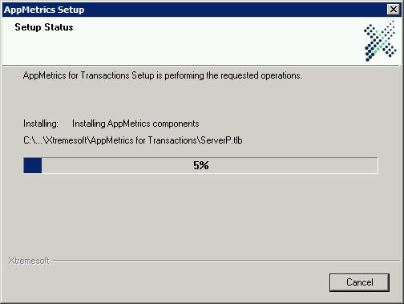
Figure 5-9 Setup Status Window
Once setup has installed the AppMetrics Agent software, the Monitor Templates window will appear indicating which templates were installed. The templates installed should match those shown below in the Monitor Templates window, Figure 5-10.
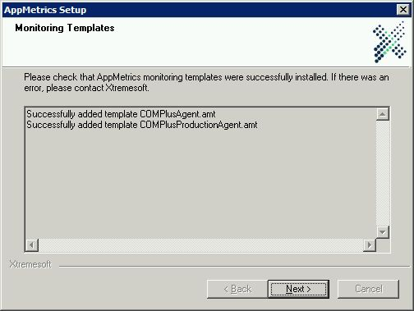
Figure 5-10 Monitoring Templates Window
Note: If the monitor templates don’t match the above list, please contact Xtremesoft support.
- Click Next. A computer reboot is required in order to complete AppMetrics installation. The reboot may be delayed by selecting Reboot later.
Figure 5-11 Reboot Option Window
- Click Next.
This opens the Installation Complete window.
Figure 5-12 Installation Complete Window
Note: AppMetrics will not function correctly until you reboot the machine.
- If you wish to skip viewing the Readme file before exiting, uncheck the View readme.txt checkbox.
- Click Finish.
Before using AppMetrics ensure that the computer has been rebooted.
You will now need to install the AppMetrics Agent software onto each of the application servers that you wish to monitor.
Once the Agent software has been installed on the application servers you may wish to ensure that the DCOM Configuration Settings are performed as described in Chapter 3: Distributed COM (DCOM) Security. You will then need to add additional user accounts to AppMetrics via the ATXAddUser.cmd file as described in DCOM Launch and Activation Permissions on page 13.

AppMetrics Console and Reports Installation

Pre-install Checklist
- Verify that your environment meets the hardware and software requirements listed on page 7.
- Ensure that you have read Chapter 3: Security Requirements and that you have a domain account available for the AppMetrics service, or you that have decided to use the Local System account. Optionally, for non-trusted domains, ensure that you have taken the steps outlined for that environment.
- If at all possible, install AppMetrics from the machine console rather than through Terminal Services. Terminal Services has its own set of security settings that can sometimes cause problems with a remote install.
- Ensure that you have your AppMetrics license key available.

Console and Reports Install Procedure
Note: This procedure is only necessary if you plan on installing the AppMetrics console onto a machine in order to use it for remote access to the AppMetrics Manager and Agent consoles. If you simply wish to run the reports from a different computer, you may copy the AppMetrics.xls file from the AppMetrics Manager computer’s \Program Files\ Xtremesoft\AppMetrics for Transactions folder to the desired location on the remote machine.
- Log on to the computer with a Windows account that has local Administrator privileges.
- If you are installing from a CD-ROM, proceed to step 4.
- If you are installing AppMetrics from a web download, double click the downloaded file from Windows Explorer, follow the instructions to extract the setup program, and then proceed to step 7.
- Place the AppMetrics CD-ROM into the CD-ROM drive.
- Use Windows Explorer to open the root folder on the CD-ROM
- Double-click Setup.exe.

After the initial Xtremesoft splash screen, the Welcome window appears (Figure 6-1).

Figure 6-1 Welcome Window
- Click Next.
This opens the License Agreement window (Figure 6-2).
Figure 6-2 License Agreement Window
- After reading the license agreement and you accept the terms of the agreement, click Yes.
This opens the Customer Information window (Figure 6-3).
Figure 6-3 Customer Information Window
- Enter your user name, your organizations name, and the license key sent to you.
- Click Next.
The AppMetrics Software Selection window will appear (Figure 6-4).
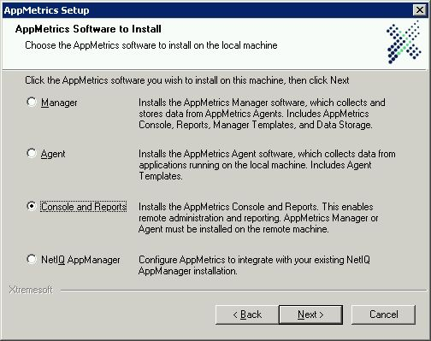
Figure 6-4 AppMetrics Software Selection Window
- Choose the Console and Reports selection, and then click Next.
This opens the Setup Type window (Figure 6-5).
Figure 6-5 Setup Type Window
- Choose the install type. Typical is recommended. Click Next.
This opens the Destination Folders window (Figure 6-6).
Figure 6-6 Destination Folders Window
- If you wish to select the drive or folder in which to install the software, click the respective Program Files Browse button, and then select the desired folder. Otherwise, accept the default location.
- Click Next.
Note: You may receive a Confirm New Folder prompt if the specified folders do not exist on the machine (except for the SQL Database Files folder as previously noted). Click Yes to accept the creation of the new folder(s).
This opens the Service Run As Account window (Figure 6-7).
Figure 6-7 Service Run As Account Window
- If using a domain account for the AppMetrics service, specify the domain, username, and password in the appropriate fields.
- If using the Local System account for the AppMetrics service, select the Local System Account radio button. Please refer to the AppMetrics Service Account section on page 8 for additional requirements when using the Local System account.
- If no domain is present, enter the local computer name and user account information. Please refer to the AppMetrics Service Account section on page 8 for further information on setting up the account in cross-domain and non-trusted domain monitoring situations.
Note: This window verifies that the passwords match each other. It does not verify the username and password combination. If you enter an incorrect combination and then complete the install, you can either correct the combination after the install by using the Services console in Windows, or running AppMetrics install again in Repair mode.
- Click Next.
This opens the Select Program Folder window (Figure 6-8).
Figure 6-8 Select Program Folder Window
- Enter the name of the Start Menu Folder in which to add the AppMetrics program entries, or accept the default name.
- Click Next.
Installation will now begin, and the Setup Status window (Figure 6-9) will display the current installation operations.
Figure 6-9 Setup Status Window
Once setup has installed the AppMetrics Console and Reports software, setup will prompt for a reboot (Figure 6-10).
A computer reboot is required in order to complete AppMetrics installation. The reboot may be delayed by selecting Reboot later.
Figure 6-10 Reboot Option Window
- Click Next.
This opens the Installation Complete window.
Figure 6-11 Installation Complete Window
Note: AppMetrics will not function correctly until you reboot the machine.
- If you wish to skip viewing the Readme file before exiting, uncheck the View readme.txt checkbox.
- Click Finish.
Before using AppMetrics ensure that the computer has been rebooted.
Once the software has been installed, you may wish to ensure that the DCOM Configuration Settings are performed as described in Chapter 3: Distributed COM (DCOM) Security. You will then need to add additional user accounts to AppMetrics via the ATXAddUser.cmd file as described in DCOM Launch and Activation Permissions on page 13.
The AppMetrics Console may now be connected to any AppMetrics Manager or Agent computers on the network, as described in the AppMetrics documentation.
Additionally, the AppMetrics reports may be run against the collected data stored in the SQL Server database.

Installing AppMetrics on a Single Computer in a Test Environment

Pre-install Checklist
- Verify that your environment meets the hardware and software requirements listed on page 5 for the AppMetrics Manager and AppMetrics Agent software.
- Ensure that you have read Chapter 3: Security Requirements and that you have a domain account available for the AppMetrics service, or you that have decided to use the Local System account. Optionally, for non-trusted domains, ensure that you have taken the steps outlined for that environment.
- If at all possible, install AppMetrics from the machine console rather than through Terminal Services. Terminal Services has its own set of security settings that can sometimes cause problems with a remote install.
- Ensure that you have your AppMetrics license key available.
- Ensure that TCP/IP is enabled for the SQL instance you will be using for AppMetrics. This can be verified through the SQL Server Configuration Manager.
- Verify that the SQL Server instance you will be using for AppMetrics is running.
- If you are installing the AppMetrics Manager onto a SQL cluster, please contact Xtremesoft Support.

Custom Install Procedure
- Follow steps 1 through 11 for the AppMetrics Manager install, pages 15 - 17.
Note: This procedure may also be performed after the AppMetrics Manager has already been installed by running AppMetrics setup in Modify mode. This can be done by running AppMetrics setup from Add/Remove programs (or Programs and Features in later operating systems), and then selecting Modify from the Modify, Repair, or Remove window.
This opens the Setup Type window (Figure 7-1).
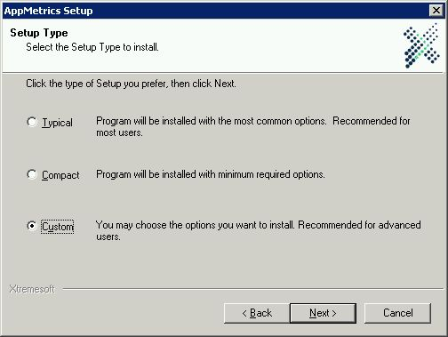
Figure 7-1 Setup Type Window
- Choose the Custom setup type. Click Next.
This opens the Destination Folders window (Figure 7-2).
Figure 7-2 Destination Folders Window
- Proceed with steps 13 through 22 on pages 18 - 22.
- Click Next.
Note: You may receive a Confirm New Folder prompt if the specified folders do not exist on the machine (except for the SQL Database Files folder as previously noted). Click Yes to accept the creation of the new folder(s).
The Select Components window will appear (Figure 7-3).
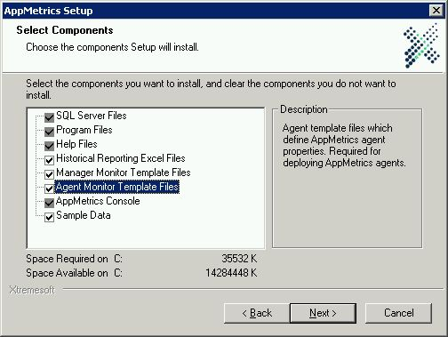
Figure 7-3 Select Components Window
- Select the Agent Monitor Template Files checkbox and check it.
- Click Next.
- Continue with steps 23 through 38 on pages 22 - 27.
Once setup has installed the AppMetrics Manager and Agent software, the Monitor Templates window will appear indicating which templates were installed. The templates installed should match those shown below in the Monitor Templates window (Figure 7-4).
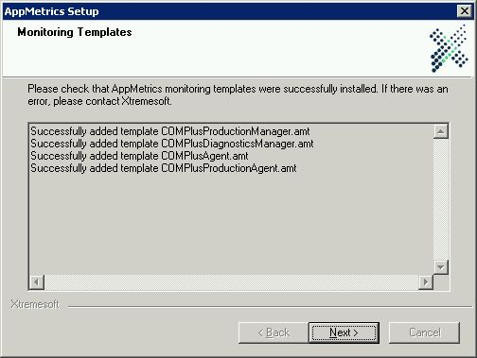
Figure 7-4 Monitoring Templates Window
Note: If the monitor templates don’t match the above list, please contact Xtremesoft support.
- Click Next. A computer reboot is required in order to complete AppMetrics installation. The reboot may be delayed by selecting Reboot later.
Figure 7-5 Reboot Option Window
- Click Next.
This opens the Installation Complete window.
Figure 7-6 Installation Complete Window
Note: AppMetrics will not function correctly until you reboot the machine.
- If you wish to skip viewing the Readme file before exiting, uncheck the View readme.txt checkbox.
- Click Finish.
Before using AppMetrics ensure that the computer has been rebooted.
Once the software has been installed, you may wish to ensure that the DCOM Configuration Settings are performed as described in Chapter 3: Distributed COM (DCOM) Security. You will then need to add any additional user accounts to AppMetrics via the ATXAddUser.cmd file as described in DCOM Launch and Activation Permissions on page 13.

Uninstalling AppMetrics

The AppMetrics uninstall procedure will automatically delete all existing and program files.
For AppMetrics Manager installations, the uninstall procedure will also delete monitors, log files, data directories, and database files for the monitors. Accordingly, before uninstalling AppMetrics from a Manager machine, you should back up any monitor log files and database files that you may require in the future. Additionally, AppMetrics agents tied to a monitor should be removed from the AppMetrics monitor prior to removing the manager, unless the AppMetrics Agent software is also being removed.
For AppMetrics Agent installations, the uninstall procedure will also delete each AppMetrics Agent defined on that computer. The individual agents should be removed from each associated AppMetrics monitor on the AppMetrics Manager console, unless the AppMetrics Manager software is also being removed.

To Uninstall AppMetrics
- Log on to the machine with a Windows account that has local Administrators and AppMetrics Administrators privileges. SQL Server sysadmin rights will also be needed for monitor database removal on an AppMetrics Manager uninstall.
- Close all AppMetrics programs, including AppMetrics Console and/or AppMetrics Reports.
- Run the AppMetrics setup program from Add/Remove Programs, or Programs and Features on later operating systems.
- In the AppMetrics Setup screen, click Remove, and then click Next.
- Follow the remaining prompts to complete the uninstall procedure.
- Reboot the computer.

- Monitoring .Net Serviced Components with AppMetrics

In order for AppMetrics to monitor .Net Serviced Components, the component must be configured to fire the necessary COM+ instrumentation events. To accomplish this it is necessary to define a public interface for the component and to set certain attributes. The following code sample illustrates the needed attribute settings and interface.

Code Prerequisites
// Here we define the public interface for our Example class.
[ ComVisible( true ) ]
public interface IExample
{
int Method1(int Parm1);
}

// The class interface type MUST be set to AutoDual
[ ClassInterface(ClassInterfaceType.AutoDual) ]
[ ComVisible( true ) ]

// The following attribute is optional, but if it isn’t set in the
// code, then the “Component supports events and statistics” checkbox
// on the component’s Activation properties page must be checked
// manually in the ComponentServices management console.
[ EventTrackingEnabled ]

// JIT activation defaults to off for components which are configured in
// COM+, but is enabled automatically if automatic transactions are
// requested.
// Here we’ll set it to on in our example
[ JustInTimeActivationAttribute ]

public class Example : ServicedComponent, IExample
{
public int Method1(int Parm1)
{

return (Parm1);

}
}

Once built, the Serviced Component application would then be deployed as usual, while ensuring that it has been added to the COM+ catalog by either using the COM+ management console, or the RegSvcs.exe utility.
Additionally, it will be necessary to uninstall any existing assembly associated to the DLL which contains the serviced component code from the global assembly cache, and to install the new DLL into the cache.
This can be accomplished by navigating to the \Windows\assembly folder, locating the DLL containing the serviced components, right clicking on the DLL name, and selecting “Uninstall”.
The DLL can then be installed by dragging it from an explorer window and dropping it into the \Windows\assembly folder.
The .Net serviced components should now be ready to be monitored by AppMetrics.

- Using AppMetrics with a Firewall

AppMetrics uses the DCOM (Distributed COM) protocol to communicate. It is necessary to open up the DCOM Service Control Manager port 135, along with a specified range of dynamic ports in order for AppMetrics to communicate between the AppMetrics Manager and Agents properly.
The dynamic range depends on how many monitors you wish to use, and whether or not you intend to use other applications which make use of DCOM. There are several Windows applications and services which utilize DCOM, so you should always ensure that there are a sufficient number of ports available for your existing needs, and then add the number of ports needed for AppMetrics to that value. AppMetrics uses two dynamic DCOM ports per monitor, and two dynamic DCOM ports for the console. Therefore, you need to reserve at minimum four DCOM ports in order to run one monitor, and a set of two more for each additional monitor. You should allow for a minimum of 100 ports however due to various Windows services and applications which also require use of DCOM ports.

Checking Connectivity and Configuring DCOM Port Ranges for Use with a Firewall
- Check basic IP connectivity. Test this by ensuring that you can PING the Manager from the Agent, and the Agent from the Manager.
- Check DNS/NetBIOS connectivity (needed when entering a NetBIOS name for the application server when adding an agent to a monitor). Test this by PINGing the Manager with its computer name from the Agent, and PINGing the Agent with its computer name from the Manager.
- Check the DCOM port configuration. Test that DCOM is using TCP as its default protocol by launching DCOMCNFG from the Windows command line, or by navigating to the Component Services console from the Administrative Tools menu, and then expand the console to Component Services->Computers->My Computer, as shown below in Figure B-1.
Figure B-1 Component Services Console
- Right click on the My Computer item, and then select Properties from the pop-up menu. From there, select the Default Protocols property page, as shown below in Figure B-2.
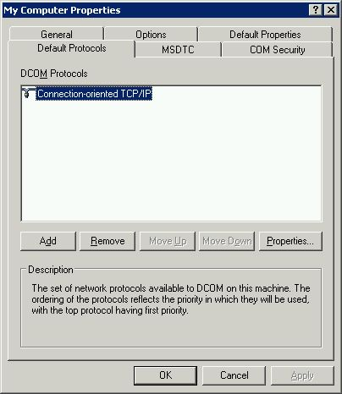
Figure B-2 Default Protocols Property Page

- Ensure that Connection-oriented TCP/IP is the highest order default protocol. If it isn’t present, use the Add button to add it to the list, and if necessary, move it to the top of the list with the Move Up button.
- Select the Connection-oriented TCP/IP item and then click the Properties button. On operating systems later than XP and Windows Server 2003, the Properties for COM Internet Services dialog will appear, as shown below in Figure B-3.
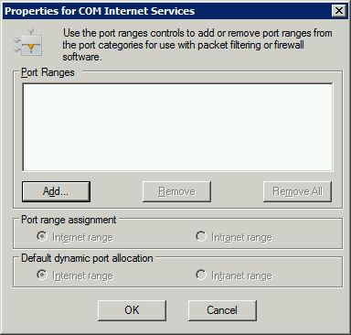
Figure B-3 Properties for COM Internet Services Dialog
Note: On Windows 2000, XP, and Windows Server 2003, the above action will immediately bring up the Add Port Range dialog.

- Click the Add button to bring up the Add Port Range dialog.
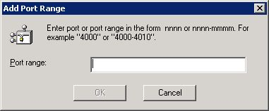
Figure B-4 Add Port Range Dialog

- You may now enter the desired port range in the form 50000-50100. When done, click OK.
- If the Properties for COM Internet Service dialog is present, ensure that both the Port range assignment and Default dynamic port allocation radio buttons are set to Internet range, and then click OK.
- The port range will then need to be configured in the firewall settings to allow TCP/IP connections within that range. Also, TCP port 135 will need to be opened for the DCOM Service Control Manager (SCM).
Note 1: It is recommended that port numbers in the range 49152–65535 be used for DCOM port allocation.
Note 2: A minimum of 100 ports should be assigned to DCOM unless there are security concerns which require a smaller range. Some applications may fail if the number of available ports is too low, so if you notice errors after making this change, you can increase the value until the errors cease to occur.

- Additional Assistance

Contact us:  If you have any questions, feel free to contact us at:  Xtremesoft, Inc.  1050 Winter Street  Suite 1000  Waltham, MA 02451 USA  +1 781 759-1220 phone  +1 781 530-3605 fax  salesgroup@xtremesoft.com  supportlist@xtremesoft.com  www.xtremesoft.com | Installation Tips:  Remember, if you installed the manager on a laptop, all monitoring will stop when the laptop is shutdown.  Make sure the interval length, the rotation frequency and the monitor detail level are configured to meet your needs. You can see the online Help for suggestions.  Other general FAQs can be found at: http://www.xtremesoft.com/solutions/trans_getstart_customer.htm

